**CMPS 356 Enterprise Application Development**

**Spring 2016 – Lab 1**

**Lab activities:**

1. **Tables**
2. 20 mins – instructor presents HTML **tables** key concepts and examples:

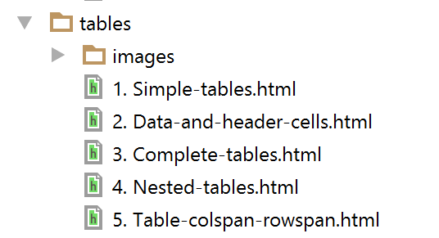

1. 30 mins - Students write a short Class Schedule using HTML tables similar to the following:

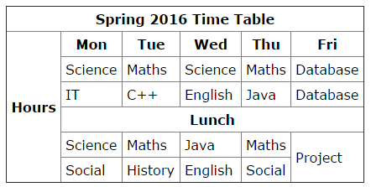

Students should push their implementation to their GitHub repository.

1. **Forms**
2. 30 mins - instructor presents HTML **forms** key concepts and examples:

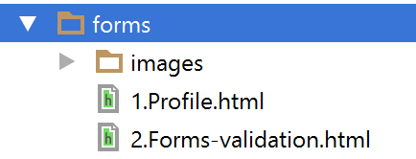

1. 40 mins - Students design and develop a simple Contact form according to the following example:

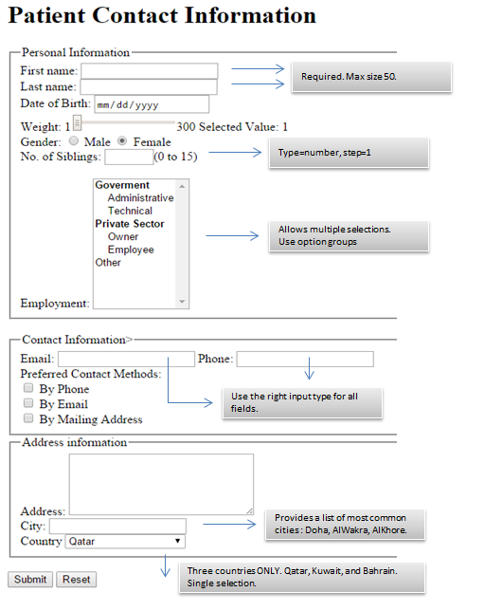

Students should push their implementation to their GitHub repository.

1. **Lab Assignment-1**
2. 10 mins – Instructor explains *Lab Assignment 1* use cases.
3. 30 mins – (Group Work) Students in group design on A3 paper the UI design. Each group present their design and get feedback from the instructor and other students. Then the students address the feedback and improve the design.

Students should push a photo of their final paper design to their GitHub repository.

1. 30 mins – (Individual Work) Each student takes the design on paper and writes the HMTL pages to implement it. Students should continue working on the assignment during the week and submit a fully working version on GitHub before next Lab.
2. During next Lab, the submission will be graded and the students can further improve their implementation using CSS and basic JavaScript.